Foreign Language Centre
______________________________________
The Foreign Language Centre at Warsaw University of Technology
would like to invite students to take
an exam in General English at level
GENERAL INFORMATION:
- The written part will take place on Thursday, June 01, 2017 at 4.00-6.30 p.m.
- The oral part will take place on Wednesday, June 07, 2017 at 4 p.m.
- Students are entitled to take the C1 exam if they have had at least 60 hours tuition at C1 level at the WUT Foreign Language Centre and if they present the recommendation of their teacher.
- Students who have taken all or part of their C1 classes outside the Foreign Language Centre are also eligible for the C1 exam but will be asked to present a certificate showing that they have completed a 60-hour course at C1 level.
THE EXAM
- Any details concerning the structure and content of the exam can be found on our website – www.sjo.pw.edu.pl
- The Foreign Language Centre will issue certificates to all students who have obtained a passing grade in the exam.
HOW TO REGISTER
The registration is open from
May 10 to May 29, 2017
- Students should register in room 419 in the WUT Main Building. The office is open on Monday and Wednesday from 9 a.m to 3 p.m and on Tuesday, Thursday and Friday from 9 a.m to 1 p.m.
- The fee for the exam is 60 zlotys. Details concerning methods of payment will be given to the candidates at the time of registration.
- The final list of students registered for the exam will be posted on SJO webpage on May 30, 2017.

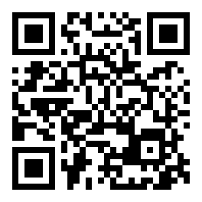
STUDENTS OF ENGLISH-MEDIUM STUDIES
Please note that passing the C1 Exam in General English does not exempt students of English-medium studies at WUT from completing their Academic English courses or from taking their final C1 Academic Exam.

For more information please write to e.chrzczonowska@sjo.pw.edu.pl

